International Spring Semester
2024

Robotics English Language

Military Academy of Saint-Cyr Coëtquidan

ERASMUS ID CODE | FGUER01
Contact | Lieutenant (OF-1) Charlie OFFERLIN  Mail : cyr.international@st-cyr.terre-net.defense.gouv.fr  Phone : +33 2 97 70 73 75
Dates | Starts : 24th January 2024  Ends : 14th June 2024  Arrival date : 23rd January 2024 (Kindly respect this date)  Dates might evolve
Student Requirements | - English language B1 or 785 TOEIC  - Bachelor of science
Application file | - Application form  - Medical Certificate  - Reduced Medical Booklet  - ID or Passport scan  - 1 ID photograph  Applications must be sent no later than 18th December 2023.
Meals & Accommodation | According to EMILYO-LoD 5 (framework), accommodation, meals, and other expenses in relation to the education are free of charge for members of European Union Basic Officer Education Institutions (http://www.emilyo.eu/node/982).

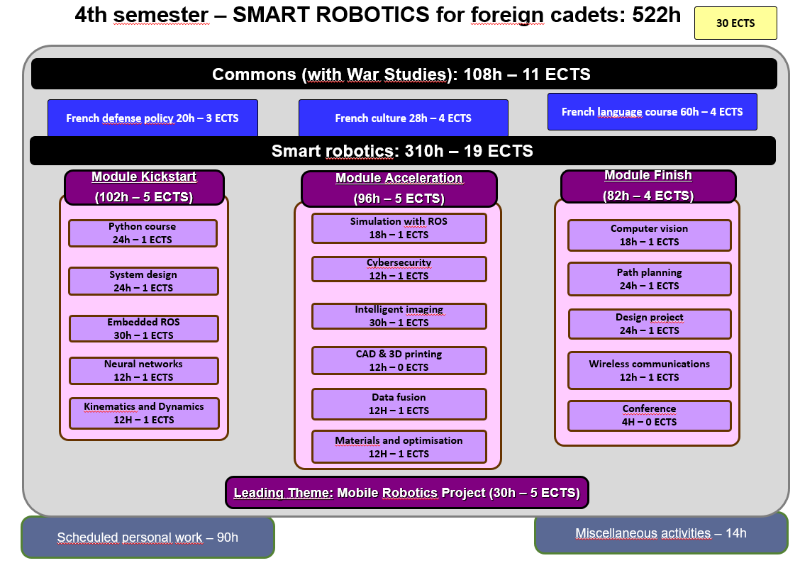
Courses Syllabus

COMMON CORE CURRICULUM

- FRENCH DEFENCE POLICY [20h / 3 ECTS]
The course offers an overview of the French military. The various lectures focus on the current French Defense policy (including the most recent White Paper, and ongoing operations), the organization of the three services and their capabilities. A particular emphasis is laid on the Army (organization, recent engagements, equipment, Special Forces and the Foreign Legion).

- FRENCH CULTURE SEMINAR [28h / 4 ECTS]
This course, is designed to provide foreign cadets with an understanding of French and French speaking culture, through geography, history, political institutions and cultural notions. Students will also be asked to work on a presentation on a topic of their choosing related to French culture or institutions.

- FRENCH LANGUAGE COURSE [60h / 4 ECTS]
This French language course is adapted according to the level of the student. Beginner courses, aim to familiarize with the basics of written and oral French language, through targeted and personalized exercises. Confirmed levels, enable students to strengthen their linguistic skills, through exercises and the study of authentic audio and written documents (films, programs, articles, books). For both levels, the aim of this course is to provide students with notions of civilization and contemporary French culture.

LEADING THEME: MOBILE ROBOTICS PROJECT [30H / 5 ECTS]
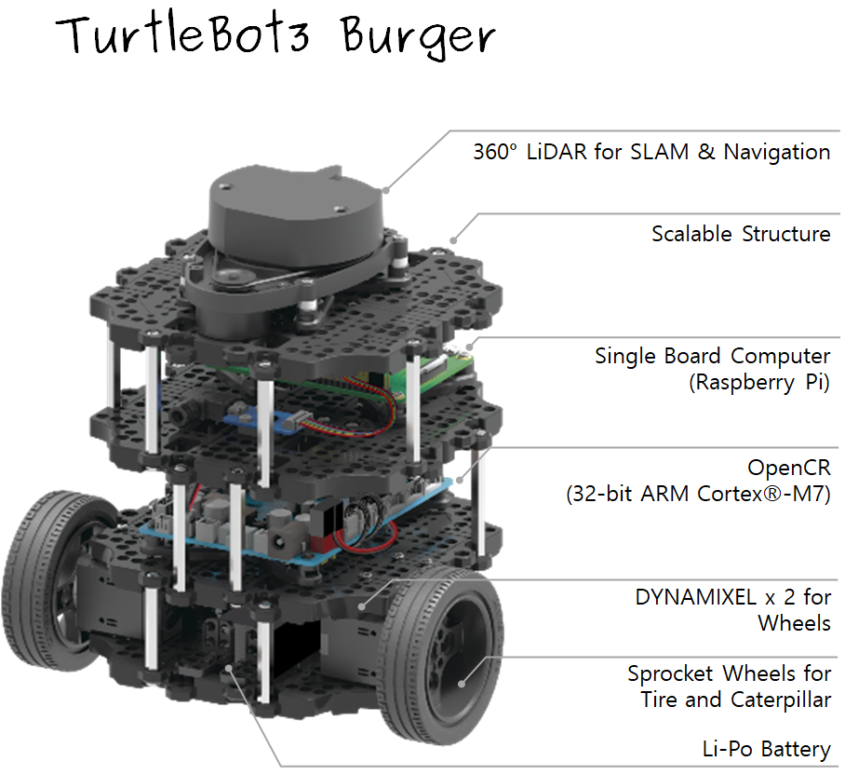
Smart Robotics is revolving around the Mobile Robotics Project. All the contents provided by the three modules (Kickstart, Acceleration and Finish) will use our mobile robotics platform as a testbed. Cadets will work in small groups using the same hardware and software tools. As of today, the mobile robotics platform will be based on a Turtlebot3 Burger robot that is powered by a raspberry pi4 single board computer and an openCR control card. Cadets will be working in small groups, using diverse methods and tools to achieve common goals and challenges.

SMART ROBOTICS

MODULE 1: KICKSTART [102H / 5 ECTS]
This module aims at introducing simultaneously the mobile robotics platform and the fundamental tools to deal with it. Supervised project time is dedicated to make sure the cadets acquire a good practice using the robots.

- Python Course [24h / 1 ECTS]
  - Language Basics
  - Integrated Development Environment
  - Data types for Robotics, Signal and Image Processing
  - Modules: scipy, numpy, pandas
- System Design [24h / 1 ECTS]
  - Risk Analysis
  - Requirements expression using SysML
  - Recipes Testing
  - System architecture description
  - System behavioral evaluation
- Embedded ROS (Robot Operating System) [30h / 1 ECTS]
  - Linux/Ubuntu on embedded devices
  - Command Line Tools
  - ROS basics: architecture, tools, communications
  - First robotics experiments
- Neural Networks [12h / 1 ECTS]
  - Optimization theory
  - Linear classification and Perceptron
  - NN functions approximation
  - Backpropagation and gradient descent
  - Framework experiment using TensorFlow/Keras
- Kinematics and Dynamics [12h / 1 ECTS]
  - Servo motor identification
  - Dynamics with experiments
  - Kinematics
  - Robotics Locomotion

MODULE 2: ACCELERATION [96H / 5 ECTS]
This module deals with introducing tools to control the robot at a higher level introducing sensors to assess the platform’s environment. Some other basic aspects like energy and security are also taken into account. The cadets will have more supervised project time to gain independence on everyday use of the mobile robotics platform.

- Simulation and ROS [18h / 1 ECTS]
  - Feedback loop control
  - Variable State control
  - 3D Simulation
  - Odometry
- Cybersecurity [12h / 1 ECTS]
  - Operating System deployment on Raspberry Pi
  - Setting Up Network & its Security
  - Cryptography Standards
  - Secured Communications
- Intelligent Imaging [30h / 1 ECTS]
  - Image Acquisition
  - Image Compression and Coding
  - Fundamentals of Image Processing
  - Features Extraction
  - Pattern Recognition
- Computer-Aided Design and 3D Printing [12h]
  - CAD using Solidworks
  - Basics of mechanical engineering
  - Structural analysis
  - 3D printing in practice
- Data Fusion [12h / 1 ECTS]
  - Conditional Probability
  - Bayesian Reasoning
  - Belief Distribution
  - Bayesian and Kalman Filtering
- Material and Optimization [12h / 1 ECTS]
  - Materials for UAV and UGV
  - Sandwich Material for Lightness and Stiffness
  - Shape Optimization

MODULE 3: FINISH [82H / 4 ECTS]
This module is more project-oriented and the cadets use more autonomous working time to achieve challenges connected to mobile robotics. The cadets will bring together more building bricks to perform more complex tasks such as detailed environment assessment and target tracking. They will also present their work during the academy’s science fair alongside the projects of all the cadets.

- Computer Vision [18h /1 ECTS]
  - From 3D to 2D and backwards
  - Multiview geometry
  - Camera calibration
  - SLAM and Visual Odometry
- Path Planning [24h / 1 ECTS]
  - Problem Formulation
  - Graph Representation
  - Optimization Methods on Graph
- Design project [24h / 1 ECTS]
Overall goal: dedicated robotic part design and implementation Graph Representation
  - Part specification and requirements
  - Part design and adjustment
  - Material optimization
  - Part printing and test
- Wireless Communications [12h / 1 ECTS]
  - Radio Communications Overview
  - Wireless Protocols
  - Software Defined Radio
- Conferences [4h]
  - RADAR

Application file documents:

- Application Form (p.9)

- Medical Certificate (p. 10)

- Reduced Medical Booklet (p. 11 – p.12)

Application Form

Military Academy of Saint-Cyr Coëtquidan
Please attach your head-and-shoulder photograph data.
Country of Origin:
Name of the Institute:

Course:
From:  (dd/mm/yy) |  | To:  (dd/mm/yy)

Male | Female | Rank | Surname | First name

Date of birth | Place of birth | Branch of Service | Major academic Field | Academic Year

Passport number | Phone number | e-mail address
ID number | Current address

Arrival at Rennes Airport (yes/no) | Arrival at Rennes rail station  (yes/no) | Arrival date (dd/mm/yy) | Time of arrival
Departure from Rennes Airport  (yes/no) | Departure from Rennes rail station  (yes/no) | Departure date (dd/mm/yy) | Time of departure

Special dietary or food requirements

Emergency contact/ Liaison staff:
Male | Female | Rank | Surname |  | First name
POC’s phone number |  |  |  | POC’s e-mail address

FRENCH MINISTRY OF DEFENSE

-------------------------
MILITARY HEALTH SERVICE

--------------------------
MEDICAL CERTIFICATE
(n°620-4/1)

SURNAME : FIRST NAME :

Birth date : Rank :

APTITUDES | Medical decision
General

Abroad & overseas

Paratrooper

Commando

Job’s restriction details
(if needed)

CONCLUSION: Date:
⁭ Aptitude without restrictions
⁭ Aptitude with restrictions Practitioner’s signature & stamp:
⁭ Inability

Reduced Medical Booklet

Surname: First Name:

Birth Date: Rank:

Medical Background
- Family :

- Medical :

- Surgical :

- Allergy :

Treatment :

Current Medical condition :

Job’s incapacity :

Height: Weight:

Blood Pressure: Pulse:

VACCINATION:

TYPE | Date of 1st injection | 2nd injection | 3rd injection
BCG
Diphtheria-Tetanus-Polio-Pertussis
Meningitis (A + C)
Hepatitis B
Measles-Mumps-Rubella
INFLUENZAE (H1N1 and seasonal)
Meningococcal Tetravalent (A + C + Y + W135
Typhoid
Hepatitis A
Yellow fever

Date : Practitioner’s stamp and signature :

